# Question 1 Code Explanation and Output

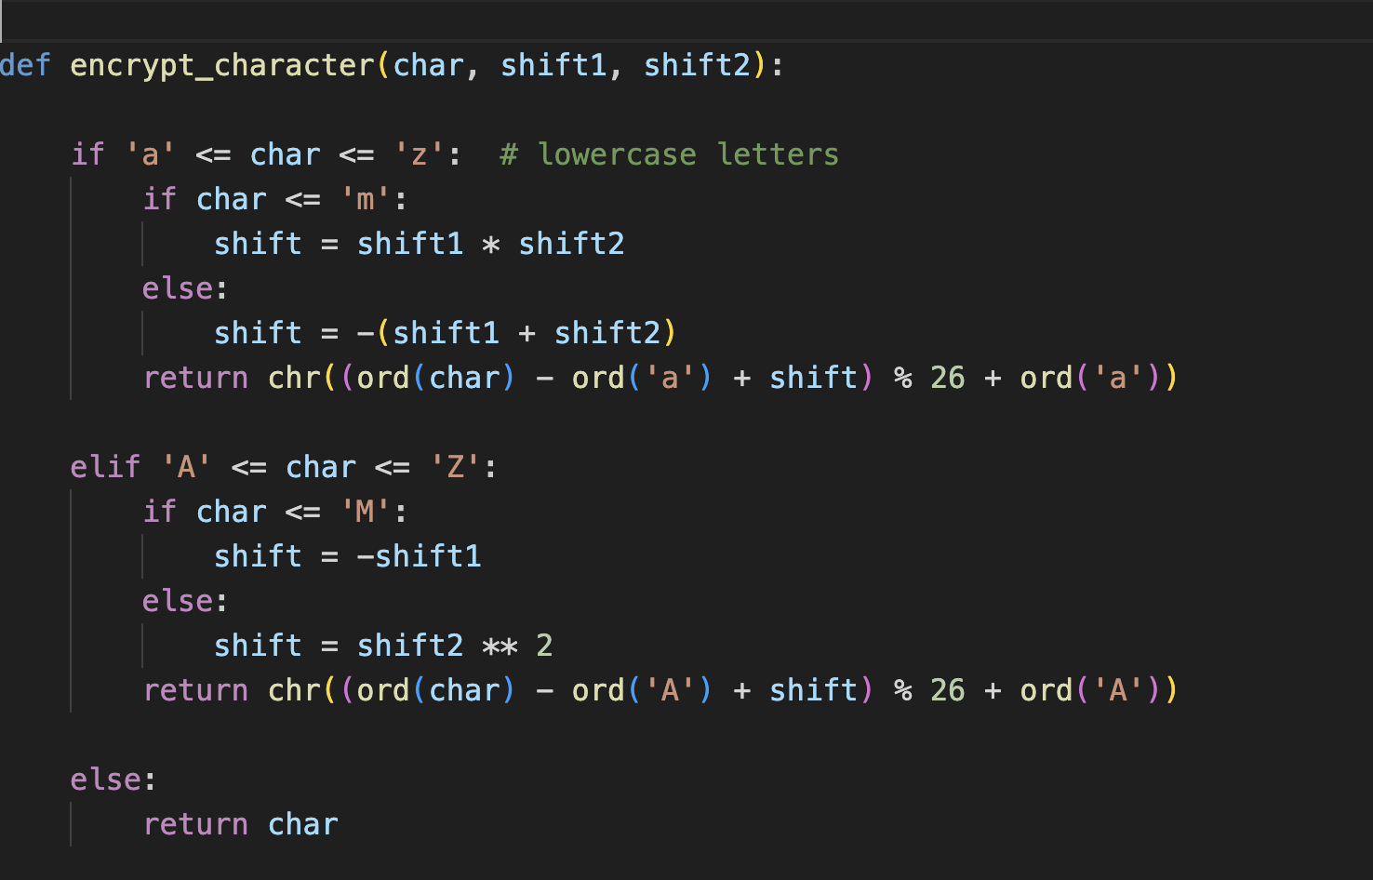

We have used python built-in function ord(char) which convert the character to its ASCII code and chr() which convert ASCII code back to a character after shifting. This function encrypts one character at a time using the shift values as per assignment requirement.

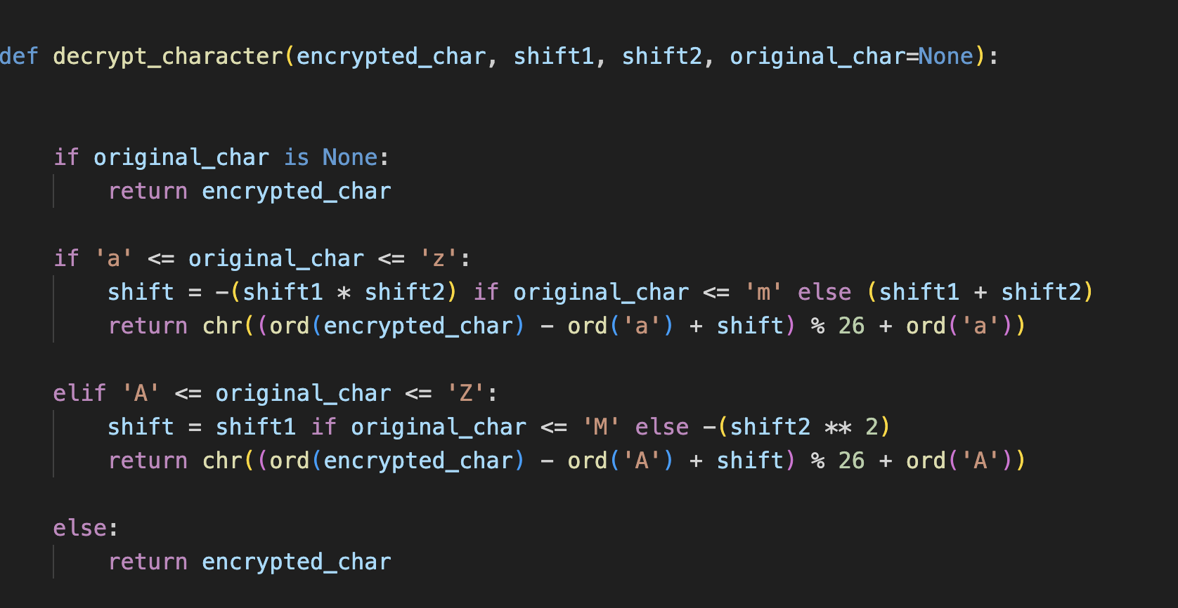

This code reverses the encryption to get original character.

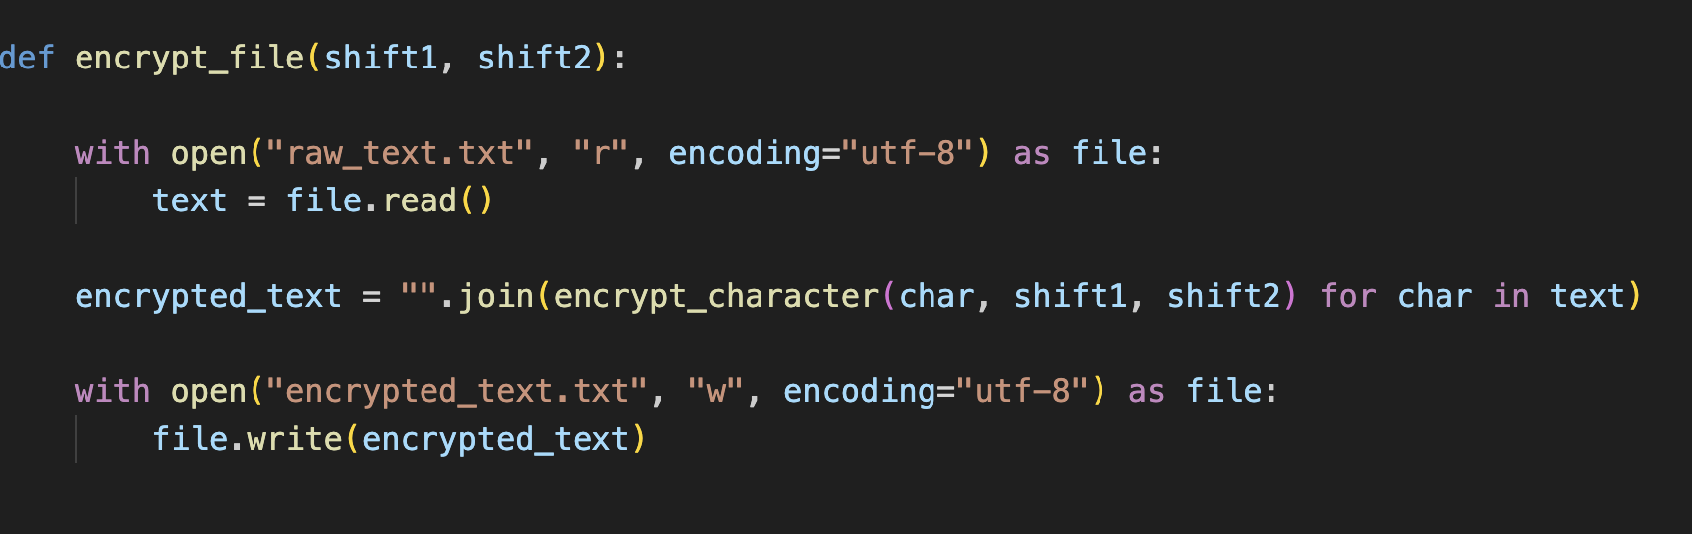

This code read the content of “raw_text.txt” file and encrypts each character and store all the encrypted character in “encrypted_text.text”.

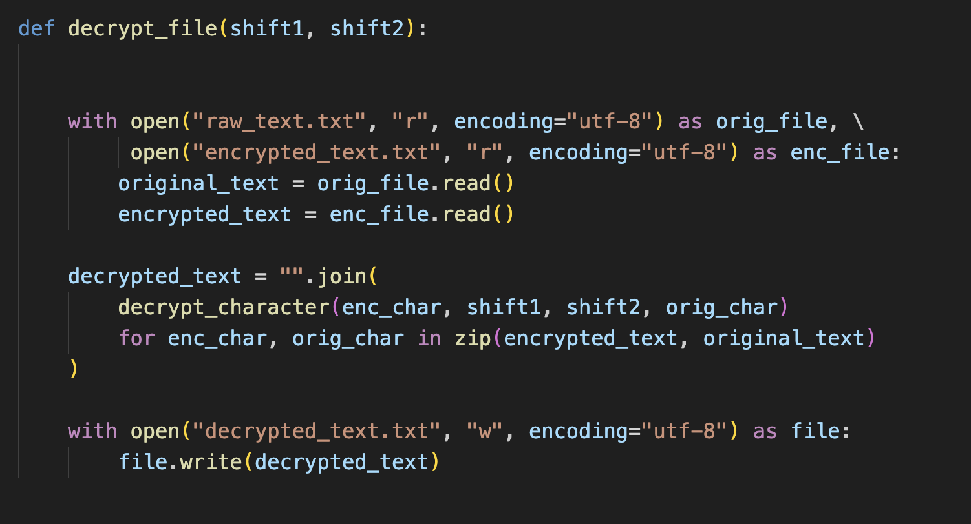

This code does exactly opposite. It open both original file and the encrypted file and read the content and decrypt all the character and store in “decrypted_text.txt”

# Example

Encrypted text

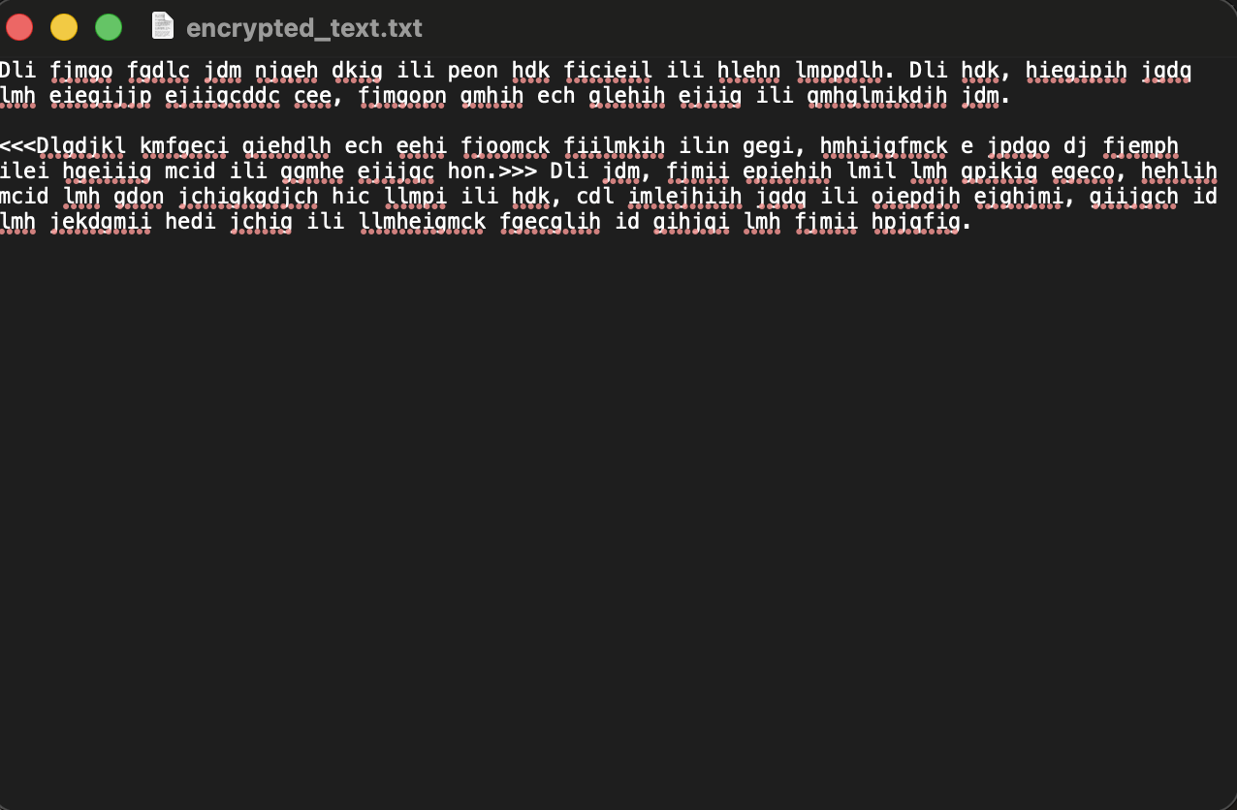

Decrypted text

